1. Provide a screenshot of the Activity13.4 folder in VS Code.

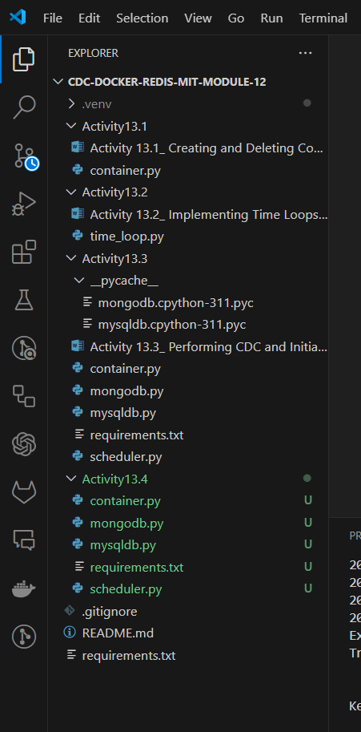

1. Provide a screenshot to show that you successfully added the code to create a Redis database *container*.

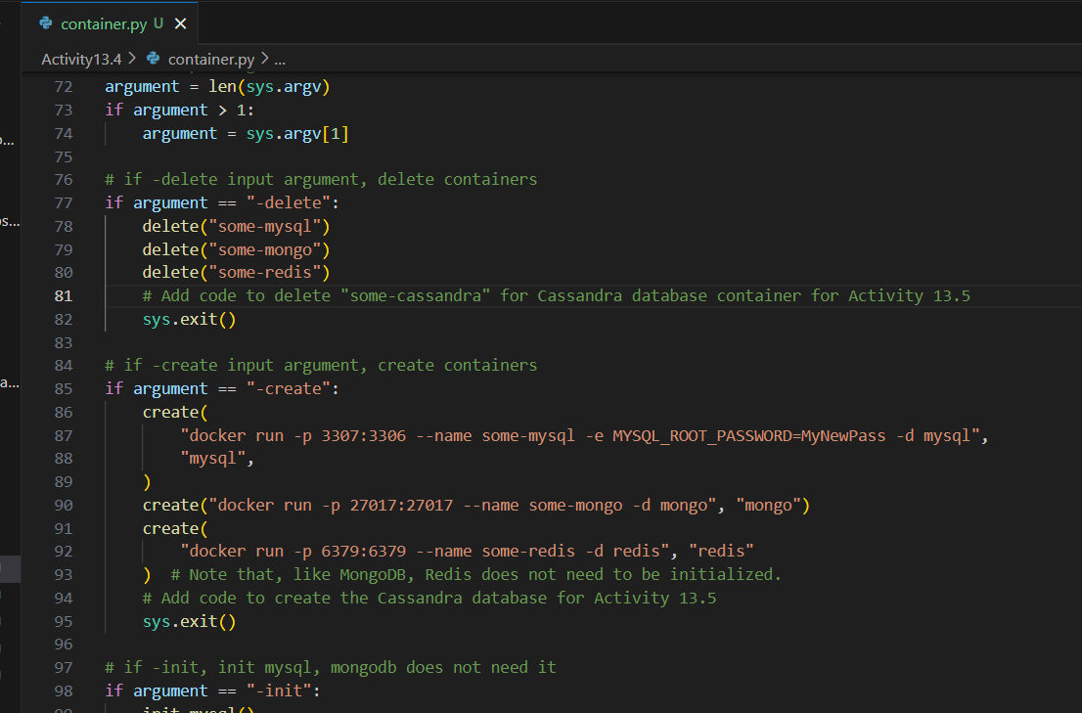

1. Provide a screenshot of the command prompt to show that you successfully executed the container.py Python program and passed -create as a parameter.

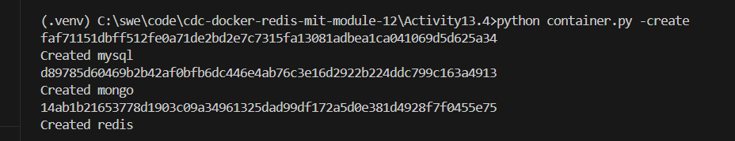

1. Provide a screenshot of your Docker desktop to show that the three *containers* (MySQL, MongoDB, and Redis) are running.

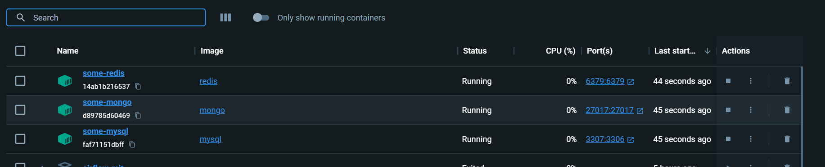

1. Provide a screenshot of the command prompt to show that you successfully executed the container.py Python program and passed -init as a parameter to initialize your databases.

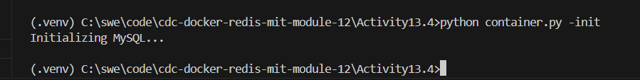

1. Provide a screenshot to show that you added the code to delete the Redis database *container*.

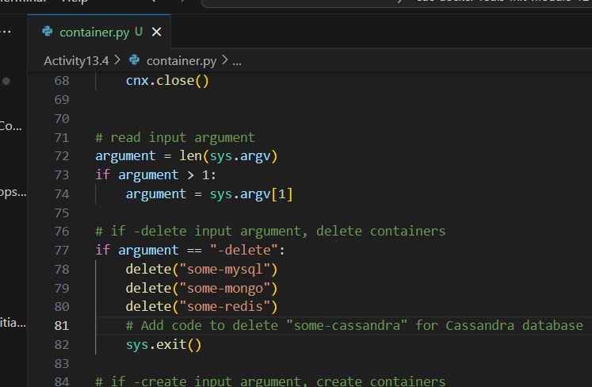

1. Provide a screenshot to show that you created a new file called redisdb.py.

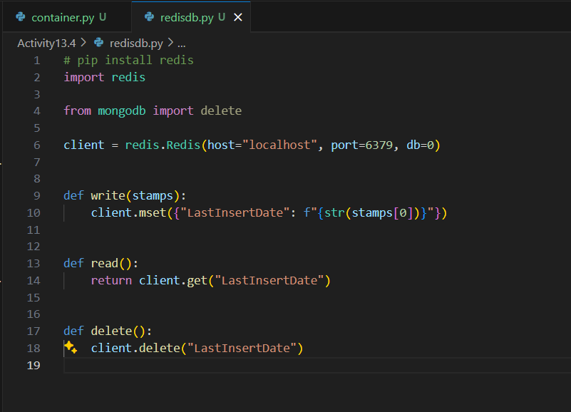

1. Provide the following five screenshots to show that you modified the scheduler.py program:
   1. Provide a screenshot to show that you uncommented the line to import redisdb to add the redisdb.py Python program to the scheduler.

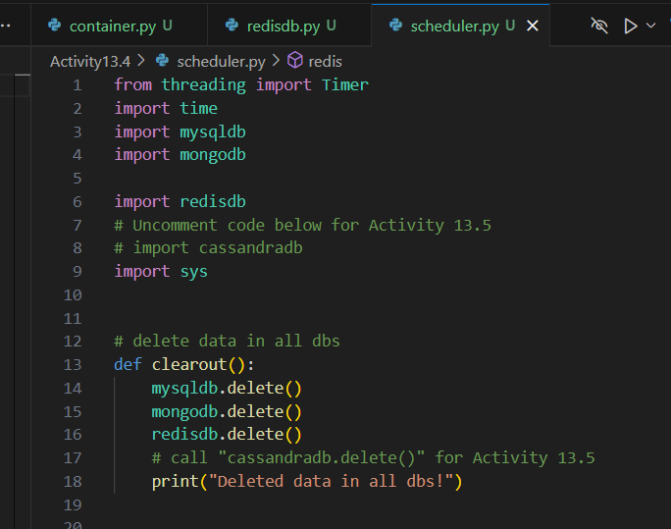

* 1. Provide a screenshot to show that you added a call to redisdb.delete() for the clearout()*function*.



* 1. Provide a screenshot to show that you created a *function* called redis().

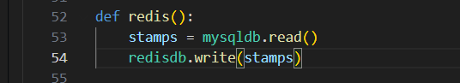

* 1. Provide a screenshot to show that you modified the verify() *function*, added a call to read data from Redis to get the Last Insert Date from the Redis database *container*, and *printed* it to the console.

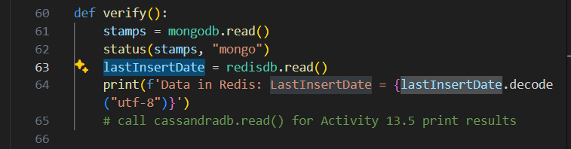

* 1. Provide a screenshot to show that you modified the timeloop() *function* and added a call to redis().

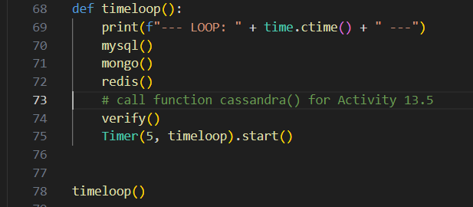

1. Provide a screenshot of the command prompt showing the output of the scheduler.py program.

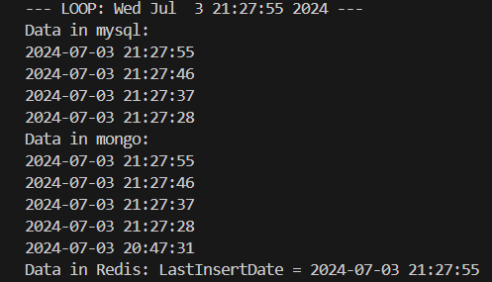

1. Provide a screenshot of the command prompt showing that you successfully ran the container.py command passing the -delete parameter.

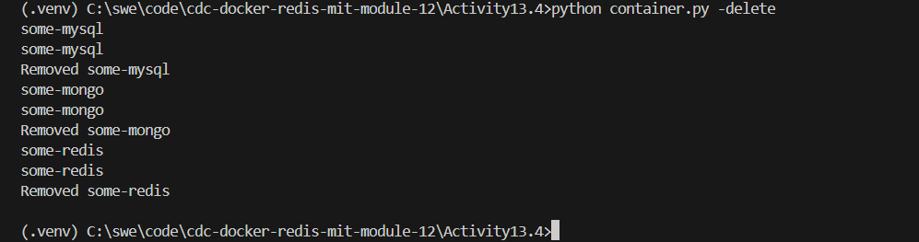

1. Provide a screenshot of your Docker desktop showing that all three database *containers* have been removed.

